Version 1.0

Revision History

|  |  |  |  |
| --- | --- | --- | --- |
| **Date** | **Version** | **Description** | **Author** |
| 12/12/2019 | 1.0 | details | Tran Van Dat |
|  |  |  |  |
|  |  |  |  |
|  |  |  |  |

Table of Contents

1. Use-Case Name 3

1.1 Brief Description 3

2. Flow of Events 3

2.1 Basic Flow 3

2.2 Alternative Flows 3

3. Special Requirements 3

3.1 < First Special Requirement > 3

4. Preconditions 3

5. Postconditions 3

6. Extension Points 3

# Payment

## Brief Description

This use-case defines the steps of giving a feedback for administrator. Customer can easily see the review of previous buyer in order to have an overview of product.

# Flow of Events

## Basic Flow

# The buyer clicks the feedback button. Then he click add feedback, enter the information and submit.

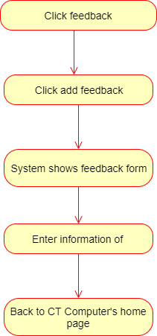

# Special Requirements

None

# Preconditions

Customer must have the credit card.

# Postconditions

No postcondition.

# Extension Points

None